RESUME

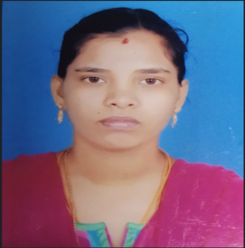
JENOVA . E
Room No : 4 , 1st Floor Meyappa Compound ,
Null Pattarai Street
Seeman Nagar, Karuppayurani ,
Madurai – 625020 .
Cont - 9655121984
e-mail: jenovanan2016@gmail.com

OBJECTIVE
Optain a position at organization where I can show my attitude , skill and patient
Knowledge for accomplishment of organization goals also to improve myself and gain experience .

EDUCATION
Dates attended PADMAVATHI SCHOOL OF NURSING , Periyanahalli ,
Dharmapuri – Dist , Tamilnadu
(Month/Year) Diploma in General Nursing And Midwifery
30-06-2009

Dates attended Madras University , Bsc Medical sociology Apperance ,
Chennai , Tamilnadu

SKILLS
Computer Knowledge Of Basic

WORK EXPERIENCE

1 ) Staff Nurse in Coimbatore Kidney Centere In Dialysis Unit ( 8th June 2009 – 31 mar 2012 )

2 ) Staff Nurse In Sri Ramachandra Hospital Porur Chennai ( 10th Sep 2012 – 4TH May 2016 )
3 ) Staff Nurse In Madurai Kidney Centre Hospital Madurai ( 1st August 2018 To Still Working )

EXTRA-CURRICULAR ACTIVITIES

Computer knowledge In Basic

INTERESTE

Improve My knowledge In Nephrology

PERSONAL DETAILS

Husband name : P. ESAI VANAN

Date Of Birth : 05 - 06 -1989

Sex : Female

Religion : Christian

Nationality : Indian

Languages : English , Tamil , Malayalam

DECLARATION

I assure that details furnished above all are true to thebest of my knowledge .

Place :

Signature

Date :

